**Create Snapshot of disk:-**

1. Go to disks and open the disk for which want to create a snapshot

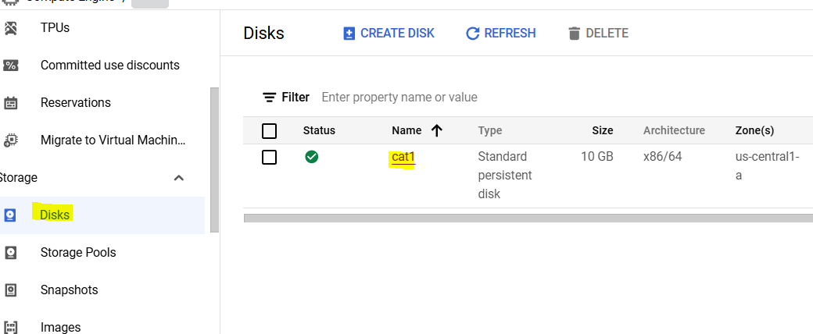

1. Click create snapshot

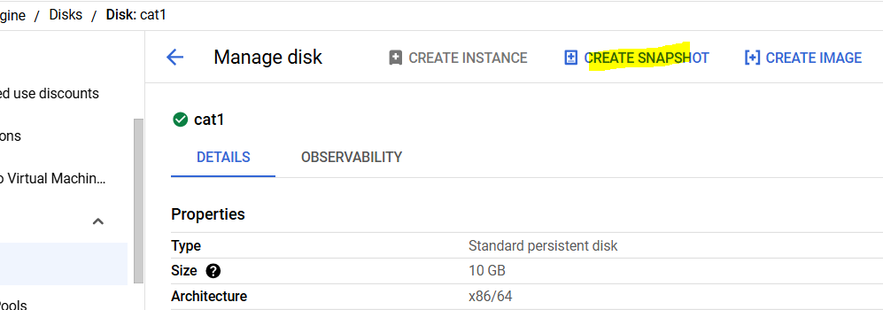

1. Give snapshot a name and select region (optionally can keep it multi-regional but for lab make it regional)
2. Click create
3. Go to snapshots and open the newly created snapshot
4. Click create Instance and show all explore options

**Snapshot Schedule:-**

1. Go to Snapshots>create snapshot schedule
2. Go through the options, no need to create a schedule, only explore the options

**Images:-**

1. Go to cat1 vm instance, open and click create machine image

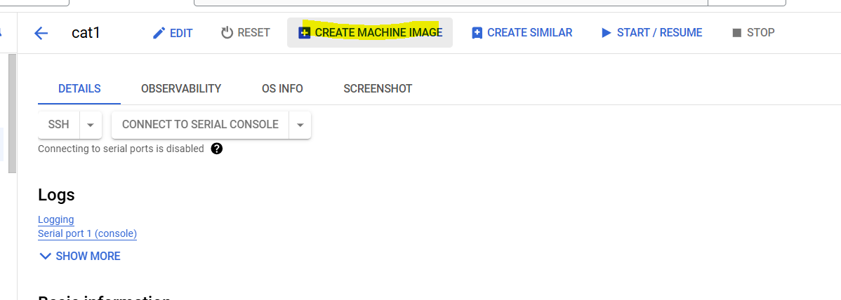

1. Give it a name, make location to regional and click create
2. Open the Image and it should show all configuration we did at cat1 vm like metadata, adding ssh key, automation scripts etc

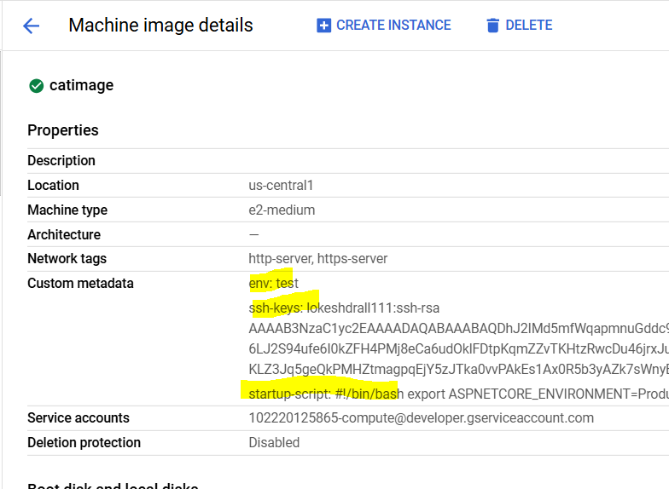

1. No click create instance

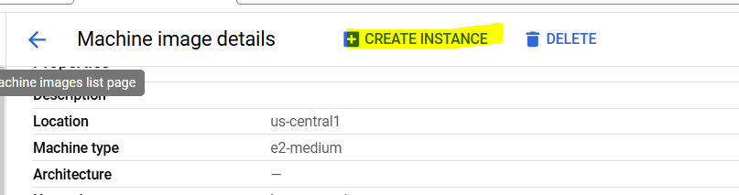

1. Show creating a instance by using this image as cat2 vm and this new cat vm should already have the Readit app running, test it by accessing from web by using its http://externalipaddress:8080 in the browser

While creating Instance, show that all configurations same as cat1 are already there, we need not to make them again

